Welcoming Schools for Students from Refugee Backgrounds 2024: A Trauma Informed Culturally Responsive Approach to Education for Auckland Schools
Programme
Refugees as Survivors NZ (RASNZ) is a specialist mental health agency based at Te Āhuru Mōwai o Aotearoa (Mangere Refugee Resettlement Centre). We have a regional team of clinicians, social workers, youth and community workers, trainers and cross-cultural facilitators. RASNZ provides professional development opportunities for practitioners across a range of disciplines, including in education, health and mental health, social service, and refugee resettlement sectors.
The Welcoming Schools programme is designed to support education sector work with children and young people from refugee backgrounds and their whanau. This practical workshop aims to enable effective practice based on the principles relevant to trauma responsiveness in schools, for refugee background students. We will offer information about the services and supports available to students and families in the Auckland region.
You will learn about:
- The refugee journey and resettlement in Aotearoa/New Zealand
- Working with collective cultures
- How trauma impacts young people’s brain, body, memory, emotions, relationships, behaviour and capacity to learn
- Responses to traumatised children and young people within education settings
- Activities and strategies that can help heal the impacts of trauma to enable improved behavioural and cognitive capacity
- Case scenarios
- Services and supports for schools/agencies

Registration Form - The workshops are free
Name:

Role:
School/Organisation/Service:

Email:
Cell:
e-mail your registration to annette@rasnz.co.nz
You will receive confirmation of your booking

Lunch will be provided- All food will be halal
Please indicate your dietary preferences
Vegan □ Dairy free □
Vegetarian □ Gluten Free □
Other____________________________________________________________________
The workshops are repeated – please choose one from the list below
Date | Time | Venue | Please tick the box
- Fri 23rd Feb 2024 | 9.00-2.30 | Waipuna Conference Centre- Carbine Room
- Fri 1st Mar 2024 | 9.00-2.30 | Waipuna Conference Centre- Conference Room 1
- Fri Aug 9th 2024 | 9.00-2.30 | Waipuna Conference Centre- Carbine Room
- Fri Aug 30th 2024 | 9.00-2.30 | Waipuna Conference Centre- Carbine Room
- Fri Sept 13th 2024 | 9.00-2.30 | Waipuna Conference Centre- Carbine Room
Workshop Details
Waipuna Conference Centre:
There is free parking available at the Waipuna Hotel and Conference Centre 58 Waipuna Road, Mount Wellington, Auckland 1060

Facilitators Bios
Carolina Millar: Registered Education Psychologist

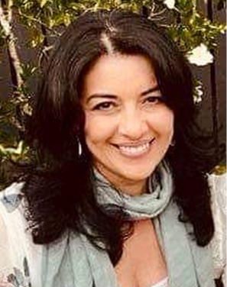
Carolina Millar is a registered Educational Psychologist with over 20 years’ experience working with the refugee and migrant sector both here in Aotearoa New Zealand and overseas. Throughout her career Carolina has supported the educational journey of students and families from refugee and migrant backgrounds with a clear focus on building strong relationships with key stakeholders, such as schools, NGOs, and other government agencies. Carolina is passionate about providing trauma-informed, evidence-based and culturally responsive care.

Annette Mortensen: RASNZ Manager Training and Development

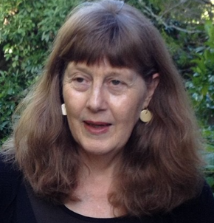
Annette has worked for over 20 years to improve healthcare responsiveness for Asian, refugee and migrant groups in New Zealand in a number of roles including as a public health nurse, project manager, researcher and educator. From 2000, Annette had the position of Refugee Health Coordinator for the Auckland Regional Public Health Service.
In 2007, Annette took up the position of Refugee and Migrant Project Manager for the NRA (Northern Regional Alliance) where she commissioned a number of studies including the Asian and MELAA (Middle Eastern, Latin American and African) Health Needs Assessments of people living in the Auckland region and the Asian Health in Aotearoa trend studies. In the same year, Annette was awarded with the Supreme Harmony Award for her contribution to Muslim relations in New Zealand by the Federation of Islamic Associations of New Zealand (FIANZ).
In 2009, she received a doctorate from Massey University. The subject of her thesis was ‘Refugees as ‘Others’: Social and Cultural Citizenship Rights for Refugees in New Zealand Health Services’. Annette currently works for Refugees as Survivors NZ (RASNZ) as the manager of Training and Development.

