|  |
| --- |
| **Welcoming Early Childhood Centres for Tamariki from Refugee Backgrounds 2025: A Trauma Informed, Culturally Responsive Approach to Preschool Education**  **Wed 28th May, 9.00-2.30pm**  **Copthorne Hotel, Palmerston North, 110 Fitzherbert Avenue** |
| **Programme** |
| Refugees as Survivors NZ (RASNZ) is a specialist mental health agency based at the Mangere Refugee Resettlement Centre/Te Āhuru Mōwai o Aotearoa. Whaea Ruth Ham who has been the head teacher at the AUT Refugee Education Centre at the Mangere Refugee Resettlement Centre for 11 years will be presenting on her team’s approach to working with preschoolers and their whānau including the use of play for traumatised children, and case studies for managing difficult times. The workshop is designed to support the education sector work with pre-schoolers from refugee backgrounds and their whānau. This practical workshop aims to enable effective practice based on the principles relevant to trauma responsiveness in the ECE sector for refugee background tamariki. |
| You will learn about:   * The refugee journey and resettlement in New Zealand * Working with collective cultures * How trauma impacts children and young people’s brain, body, memory, emotions, relationships, behaviour and capacity to learn * Responses to traumatised preschoolers in early childhood settings * Exploration of activities and strategies that can help heal the impacts of trauma to enable improved behavioural and cognitive capacity * Case scenarios * Services and supports for ECEs |
| **Registration Form - The workshops are free** |
| **Name:** |
| **Role:** |
| **ECE/Organisation/Service** |
| **Email** |
| **Cell** |
| *e-mail your registration to* [*annette@rasnz.co.nz*](mailto:annette@rasnz.co.nz)**You will receive confirmation of your booking**  **Lunch will be provided- All food will be halal**  Please indicate your dietary preferences  Vegan □ Dairy free □  Vegetarian □ Gluten Free □  Other____________________________________________________________________ |

|  |  |  |  |
| --- | --- | --- | --- |
| **Date** | **Time** | **Venue** | *Please tick the box* |
| Wed 28th May 2025 | 9.00-2.30 | Ferguson room, Copthorne Hotel, Palmerston North, 110 Fitzherbert Avenue |  |

**Facilitators Bios**

**Whaea Ruth Ham: Head Teacher for the AUT Centre for Refugee Education Early Childhood Centre, Te Āhuru Mōwai o Aotearoa (Mangere Refugee Resettlement Centre)**

Kia ora Ko Ruth Ham toku ingoa.

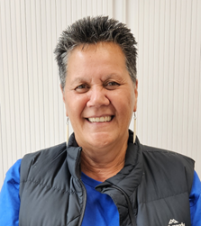I started in early childhood education as a kaiawhina in Kohanga Reo in 1986. I then went on, to start a Kohanga Reo in Manurewa, Te Timatatanga followed by a bilingual centre Best of Both Worlds. I have been at the AUT Centre for Refugee Education ECE as a head teacher for over 11 years. My role is to prepare our families for Resettlement in Aotearoa New Zealand. Our goal is to empower our children with their language and identity and to enable them to know they can be and do anything they choose.

**Carolina Millar: Registered Education Psychologist**

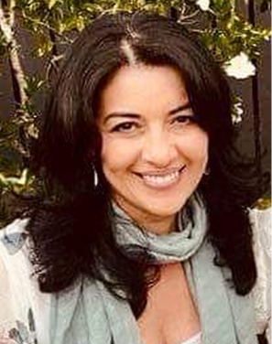Carolina Millar is a registered Educational Psychologist with over 20 years’ experience working with the refugee and migrant sector both here in Aotearoa New Zealand and overseas. Throughout her career Carolina has supported the educational journey of students and families from refugee and migrant backgrounds with a clear focus on building strong relationships with key stakeholders, such as schools, NGOs, and other government agencies. Carolina is passionate about providing trauma-informed, evidence-based and culturally responsive care.

**Annette Mortensen: RASNZ Manager Training and Development**

Annette has worked for over 20 years to improve healthcare responsiveness for Asian, refugee and migrant groups in New Zealand in a number of roles including as a public health nurse, project manager, researcher and educator. From 2000, Annette had the position of Refugee Health Coordinator for the Auckland Regional Public Health Service. In 2007, Annette took up the position of Refugee and Migrant Project Manager for the NRA (Northern Regional Alliance) where she commissioned a number of studies including the Asian and MELAA (Middle Eastern, Latin American and African) Health Needs Assessments of people living in the Auckland region. In the same year, Annette was awarded with the Supreme Harmony Award for her contribution to Muslim relations in New Zealand by the Federation of Islamic Associations of New Zealand (FIANZ). In 2009, she received a doctorate from Massey University. The subject of her thesis was *‘Refugees as ‘Others’: Social and Cultural Citizenship Rights for Refugees in New Zealand Health Services’.* Annette currently works for Refugees as Survivors NZ (RASNZ) as the manager of Training and Development.